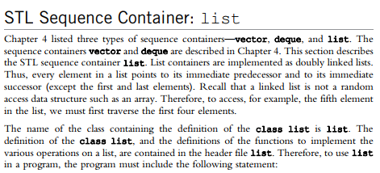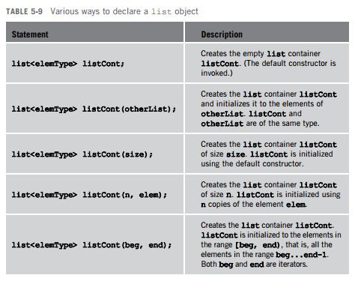  
  
  
  
  
  
  
  
  
  
  
  
  
Must include <list>  
  
  
  
  
  
  
  
  
  
  
  
  
  
  
  
  
  
  
  
  
  
  
  
  
  
  
  
  
  
